Now our game is almost complete so we need to fix few things and make it look better and then our game will be completely playable

The teacher is facing some problem when he press reset button then the color of platform changes (FYI I am not seeing this problem bit for knowledge I will observe what teacher will do )

Because lighting changes

That is why color of the material also changes so we are going to fix that now

SO to solve It teacher go to window

And then to Rendering and then to Lighting

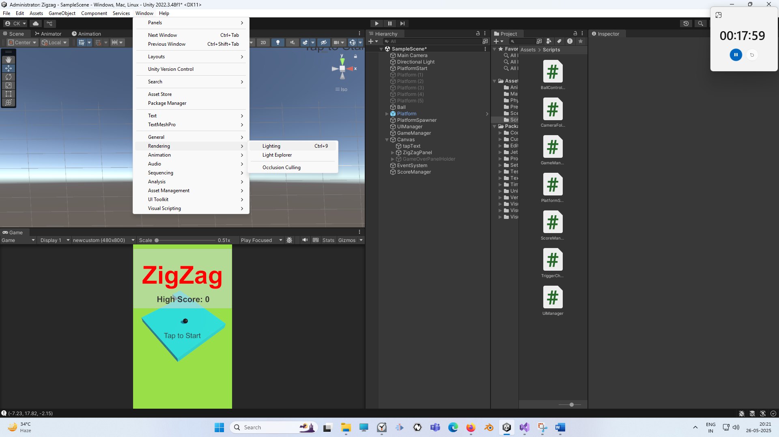

I don’t know what he is saying that it is due to auto lighting

So Now lightin winsdow opend he go to Lightmaps tab and uncheck the auto

So just click on this build.

It looks similar to below

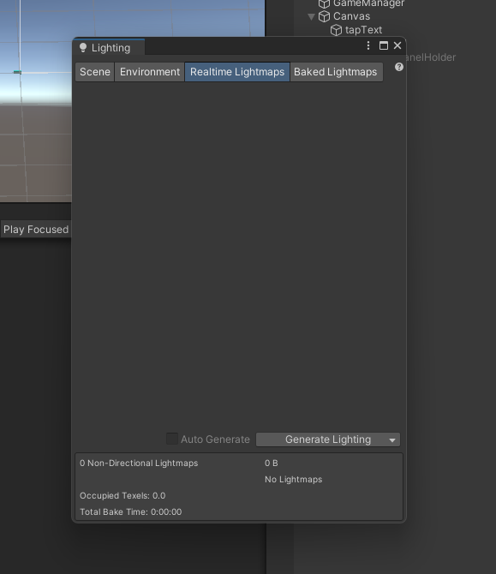

And as you can see, the scene is building our light map data and now it has created a lighting data

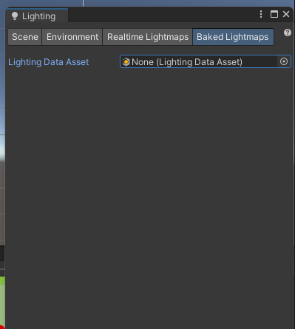

The above look similar what teacher is trying to do

Where here it is showing that lighting data asset is created(I think the newer version and default lighting asset is used)

Now when he run the game and reset, the color does not change

On emore thing that teacher observed that (I did not observe) that ball floats upward

In order to fix that.

1:15

You need to select that by selecting the ball and in inspector you can just check useGravity and set mass to high number

On more thing is that the ball has shadow but we don’t want to cast shadow of the wall

So in order to just remove the shadow we can select the ball

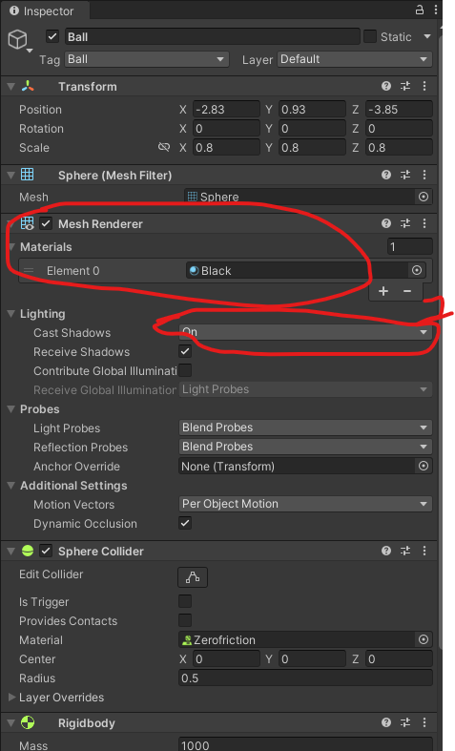

And then in Mesh Renderer component In cast shadow option as marked 1 above choose off instead of on now no shadow will be shown now

Now one problem that we see when the game is running (not start by tap) that spawning start and platform get spawned again but we don’t want to spawn them from the start we want to spawn when the game actually start

SO to do that open the platform spawning script

And while opening platform spawner script you can see as marked below we are invoking repeatedly the spawnPlatforms method

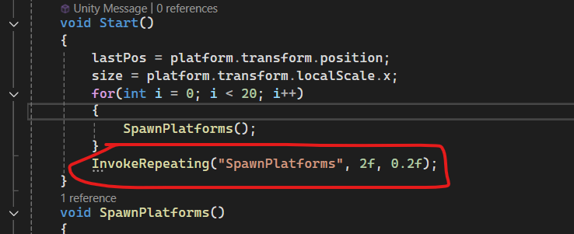

Instead of what we can do is create a separate public void startSpawnPlatforms method and inside that method place the marked code in the StartSpawningPlatforms

Now what we can do is when the game Start we can call this function from our gameManager and that’ when it will be ble to check that it needs to start spawning or not

Now go to our GameManger go to the startGame method

Then here we call another method that find a particular object from all scene (For now we have one )

SO we write GameObject.Find(“PlatformSpawner”)

So this will find the object of PlatformSpawner from all over the scene then by GetComponent<PlatformSpawner> we get the PlatformSpawner script from it and

And call the function StarSpawningPlatform

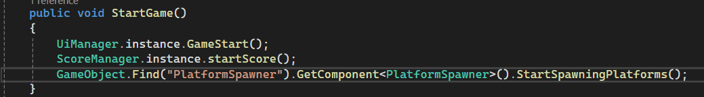

So we are finding the platform spawner in our Heirarchy here as shown below

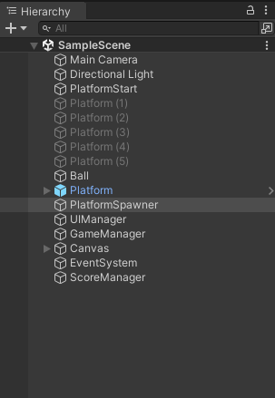

And then we are getting the PlatformSpawner component(as marked below) of PlatformSpawner object

As shown below

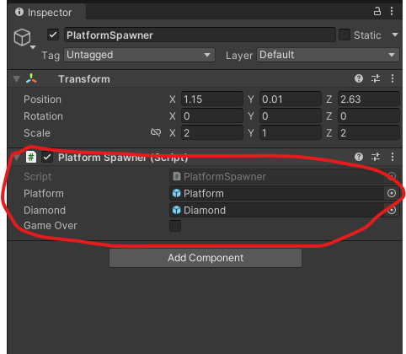

And finally we are calling the startSpawning Platform functions from it

Ok So only when we start the game after that it will start spawning our platform

And one more thing is that as you can see in the platformSpawner when the gameOver happens we are doing cancelInvoke Spawn Platforms but we are not changing this gameOver variable anywhere

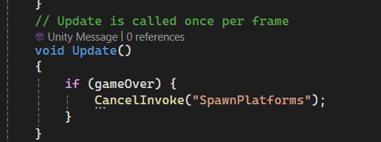

Soi what we can do here is instead of gameOver we can simply write

GameManager.instance.gameOver == true

And then we went to call cancelInvoke of SpawnPlatform

Now you can see that in Game

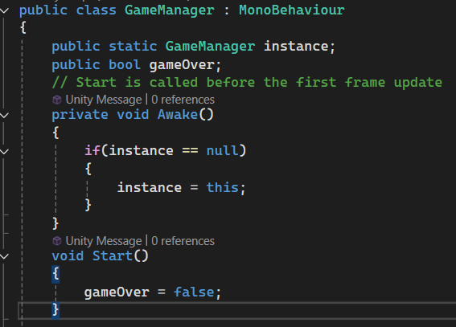

Now you can see in the starting of GameManager

You can see we are setting the gameOver to false

When the gameOver happens we will just write gameOver to true.

So when gameOver happens then gameOver set to true

PlatformSpwner will check if game Over is set to true

And then cancelInvoking our SpawnPlatforms function

No we play the game now the platform will not be spawn until the game Starts by tapping and when the gameOver then the Platform will stop spawning.

Teacher want to make the spawning platform start fast so in Platfoirm spawner he set

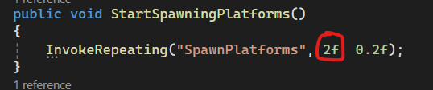

2f to 0.1f

So after 0.1f we will start spawning

OK everything working fine now all the things that we need to do is that you can see our score and highScore is not getting updated So we need to update these values and can update them from our UI Manager

The values are getting updated in our score manager, but they are not getting updated in our UI Manager so that’s why they are not getting shown on the screen So we need to update them in our UI Manager

So in our UI Manager, before activating our GameOver Panel What teacher can say is that

Here we set the value of our score

Now in UIManager you can see

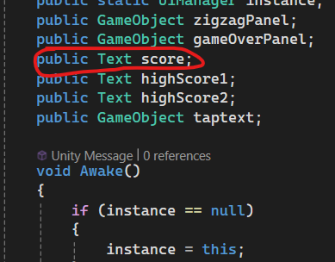

We have a variable named score. The marked one will show the score on the screen

8:25

So inside the GameOver method

We will write score.text and then assign it to the value PlayerPrefs.setInt(“score”)

Mean we are getting the value from PlayerPrefs for key score

The we were setting in score Manager

Similarly we do for highScore2 as it is the highscore are showing on the gameOverPanel and get the value for PlayerPrefs for key highscore

Highscore1 is showing in our starting menu

We need to set this highscore as well so we need to set this score before starting

So we set the highScore1 in GameStart method

But text attribute takes a string and and we are getting value in Int so we need to convert this integer to string

So easiest way will by using ToString method

So we will do something like below

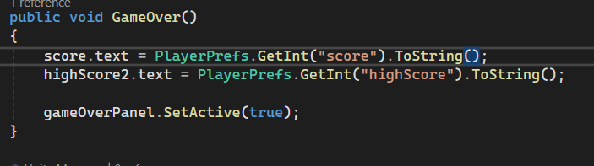

Now if we run it

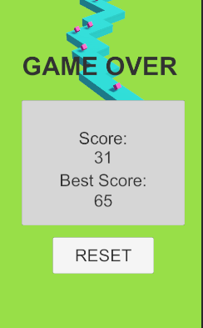

Then I am not getting any problem but Teacher score kept increasing in the GameOver Panel

But I am facing one same problem as Teacher that is if I click on reset button then

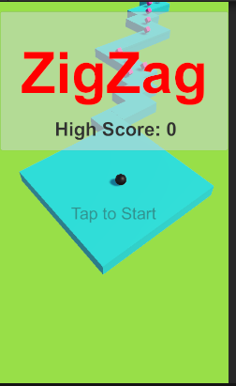

It says high score 0 but when I tap on the game then only correct high score is shown

And also replace “HighScore:” with <HighScore> but it should show HighScore: <HighScore>

So we need to fix this highscore

So our score is still going on (for Teacher)

The problem was that the teacher was not cancelling invoking the method that was repeatedly called that is incrementScore but the parent method that was enclosing the Invoke Repeating command that is StartScore

Now another problem is that it shows our highScore to be 0 but when we start our game then it shoes high score to be the actual <high score>

So we need to set “highScore: <HighScore>” from the beginning not after the tap on the screen as for now it shows “HighScore : 0” before tapping

So intead of doing it in gameStart in UIManager we are doing it in Start method

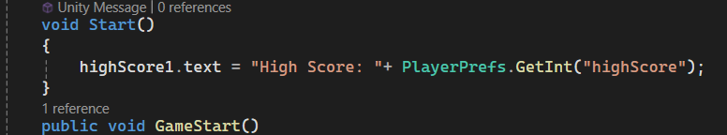

So we set it to string “High Score: ” and then concatenate it to the highScore value stored in PlayerPrefs  
we don’t need to use TOstring here as both of them as one of them is string

So when the game is running it shows us high score   
Now it wprkd now gameover panel shoes the score and if the score is greater then high score then new score becomes new high score

16:30